Taking Action: Students as Global Citizens
“Changing Perspectives about Girls’ Education”
Chantelle Savage
Over the course of the semester, this project ran as a curriculum extension project, for Years 5 and 6 students who were interested in identifying, engaging with and responding to global issues. A current focus at Hale School is to move beyond a focus on basic competencies and promote understanding at a much higher level. With the aim of fostering 21st century learning skills, the group set out to explore global issues and build their critical and ethical thinking abilities. These skills, in addition to the General Capabilities of the Australian Curriculum, became a fundamental feature of this inquiry process and project.
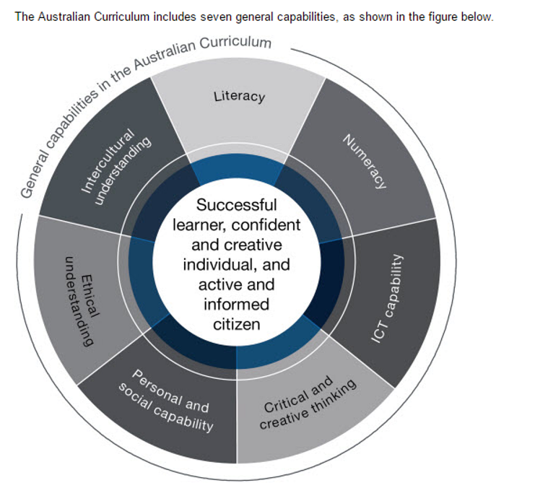
Using the Problem-Based Learning and ‘Community of Inquiry’ framework, we began the project by focusing on the Declaration of Human Rights. This led us to a key inquiry question: Are we all really born free? Further discussion led to a focus on factors that influence freedom. Both money and access to education were highlighted in this discussion; the boys unanimously agreed that gender equality in education was a crucial factor in influencing a person’s freedom.
Curriculum Links
From Year 6 Humanities and Social Sciences (HaSS) Achievement Standard.
“By the end of Year 6, students explain the significance of an event/development, an individual and/or group. They identify and describe continuities and changes for different groups in the past and present. They describe the causes and effects of change on society. They compare the experiences of different people in the past. Students describe, compare and explain the diverse characteristics of different places in different locations from local to global scales. They describe how people, places, communities and environments are diverse and globally interconnected and identify the effects of these interconnections over time. Students explain the importance of people, institutions and processes to Australia’s democracy and legal system. They describe the rights and responsibilities of Australian citizens and the obligations they may have as global citizens. Students recognise why choices about the allocation of resources involve trade-offs. They explain why it is important to be informed when making consumer and financial decisions. They identify the purpose of business and recognise the different ways that businesses choose to provide goods and services. They explain different views on how to respond to an issue or challenge.
Students develop appropriate questions to frame an investigation. They locate and collect useful data and information from primary and secondary sources. They examine sources to determine their origin and purpose and to identify different perspectives in the past and present. They interpret data to identify, describe and compare distributions, patterns and trends, and to infer relationships, and evaluate evidence to draw conclusions. Students sequence information about events, the lives of individuals and selected phenomena in chronological order and represent time by creating timelines. They organise and represent data in a range of formats, including large- and small-scale maps, using appropriate conventions. They collaboratively generate alternative responses to an issue, use criteria to make decisions and identify the advantages and disadvantages of preferring one decision over others. They reflect on their learning to propose action in response to an issue or challenge and describe the probable effects of their proposal. They present ideas, findings, viewpoints and conclusions in a range of communication forms that incorporate source materials, mapping, graphing, communication conventions and discipline-specific terms.” (http://www.australiancurriculum.edu.au/humanities-and-social-sciences/hass/curriculum/f-10?layout=1#page=2&yl-)

Philosophy & COI – Nuts & Bolts
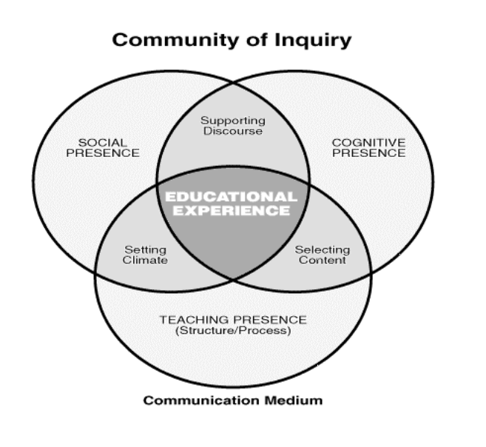
- What is Philosophy? Thinking about thinking
Questions vs statements
Philosophy Skills
The magic word … because
- Physical Space – chairs in a circle, everyone can easily see everyone else

- Establish environment – The Rules of Philosophy (can assign each rule a number so reminders during COI are non-verbal, or other visual reminders can be used)

Teacher is one of the group, rather than the expert. The teacher facilitates. Don’t give your opinion as the boys may think that is the right answer, or what you’re seeking to hear.

- Could have individual journals to reflect in
Preparation before each session
- Materials (stimulus, activity, timing planned out)
- Room physically ready
- Philosophy Prompts & Displays
First Session
- What is philosophy?
(Thinking about thinking; questions vs statements; Philosophy Skills; the magic word … because)

- Establish environment
(how we’re sitting; The Rules of Philosophy; using accountable talk)
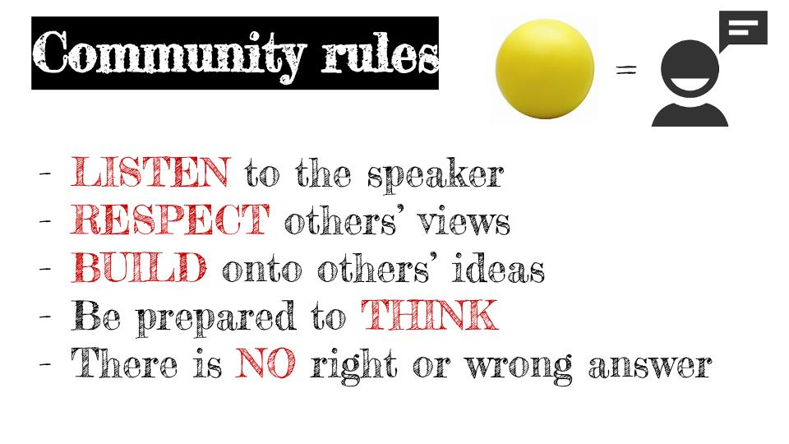
- Stimulus (shared experience) – picture book, video clip, newspaper article – the ‘wondering trigger’

- Questioning
Write each question on a strip of paper with their initials. Copy their words exactly – a word change can alter their intended meaning. Don’t worry if questions are similar. If a question seems unrelated, ask them what prompted them in the stimulus to think of that.

- Introduce ‘Question Quadrant’.

- Place questions in each quadrant. Model how to form a question for any sections lacking. Give more explicit teaching or support that you otherwise would, being the first session.
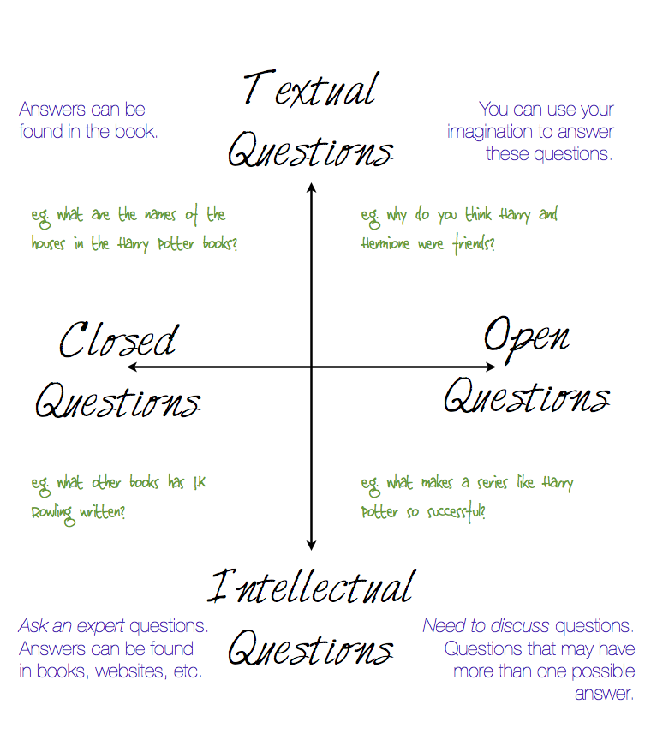

- Connecting Questions & Themes
Identify main idea of each question (from last time) and group them into themes on the carpet. Teacher to note down each main idea/theme on the whiteboard to build a list.
Second Session
- What is philosophy?
(Thinking about thinking; questions vs statements; Philosophy Skills; the magic word … because)

- Establish environment
(How we’re sitting; The Rules of Philosophy; blue brain)

- Revisit stimulus & question quadrant

- Concept Game / Values Line (teacher will have chosen the theme from those brainstormed last time and prepared it). Each boy (or in pairs) is given an object/statement card and they need to decide where to place it on a spectrum, justifying why as they do it. Once a card is down, it can’t be moved. Once all cards are down, can open discussion and debate to all boys and all cards and their placement.
Future Sessions
- Warm-ups like Thunderstorm or Bunny Ears (taken from ‘Philosophy With Kids: More Ideas and Activities’)

- Analogies (based on themes explored in concept games)
Happiness is like …
Learning is like …
Friendship is like …
Tools for Discussion
- Ask for examples, offer counter examples
- Consider alternatives
- Make distinctions (how is this different from that?)
- Allow some ‘waiting time’. Allow time for everyone to contribute
- -move from concrete examples to abstract concepts
- Requests reasons
- Watch for contradictions
- Identify assumptions
- Make inferences (move from reasons to conclusions)
- Focus on the issue: have we lost track of what we are discussing?

References/Resources
http://www.oneworldcentre.org.au/
http://p4c.com/if-then/issue-1-community-inquiry
https://coi.athabascau.ca/coi-model/
http://www.philosophywa.com.au/

